The Mayan Ball Game
The first organized team sport http://www.ballgame.org
What is the MesoAmerican world?

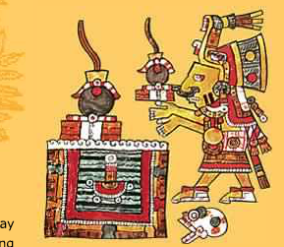
Explore Game:
Ball
What is the ball mostly made of?

What is sometimes found in the ball?

What is happening in the picture on the right -
(Click on photo on game)

What are two primary resource on this webpage and why?

Uniforms
Yuguito

Yoke

Palma

How do we know that ancient Mayans wore these things?

Courts

Why was the court built in the shape of an I?

What did the music sound like? What instruments?

What are three other things found on the court and what is it purpose? (Click on Gallery of Artwork from the courts!)

Game
How is the game played?

What happens to the losers? (Click on Chichen Itza when you open this box) Please describe what you see!

When you are finished answer the questions please play the game!

