Name: _______________________________________ Period: _________
LG: 3 REDO: Advantages & Disadvantages
What advantages does each side have going to war? What disadvantages does each side have? What strategies allowed the colonist to win? What are the terms of peace?

What advantages/disadvantages does each side having going into war? Name 5 for each side.

American British

Advantages:

Disadvantages:

What is one thing each would say if they were talking smack to each other before the war started. Plus what is one thing each would be thinking before the war started. Make references to chart above. Need to be historically relevant and can’t be yo mama jokes.

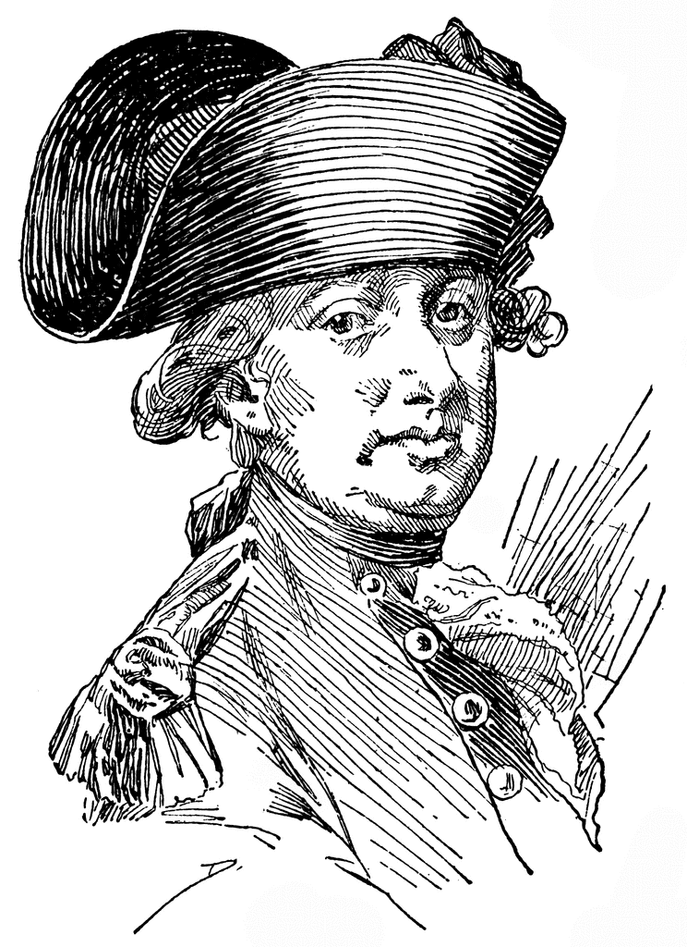
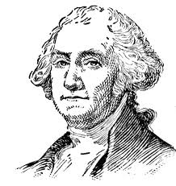

George Washington
Charles Cornwallis

